**Jane Doe’s Portfolio**

**Project Title:** My Portfolio

**Team Members:**

Anna Hou

Taruna Suryawanshi

Samantha Erickson

**Schedule**

* **Face-to-face**
  + **Monday on campus in the library**
* **text messaging**

**email**

1. Our team is suited for building a web programming team because we are college students with experience in web page design, having taken CIS 332 Web Programming 1.

2. We propose a faux portfolio website for an art student to submit to potential employers. This website will include an introduction page, links to our students' social media accounts, their resumes, cover letter(s), and examples of their work.

3. Website Diagram Here

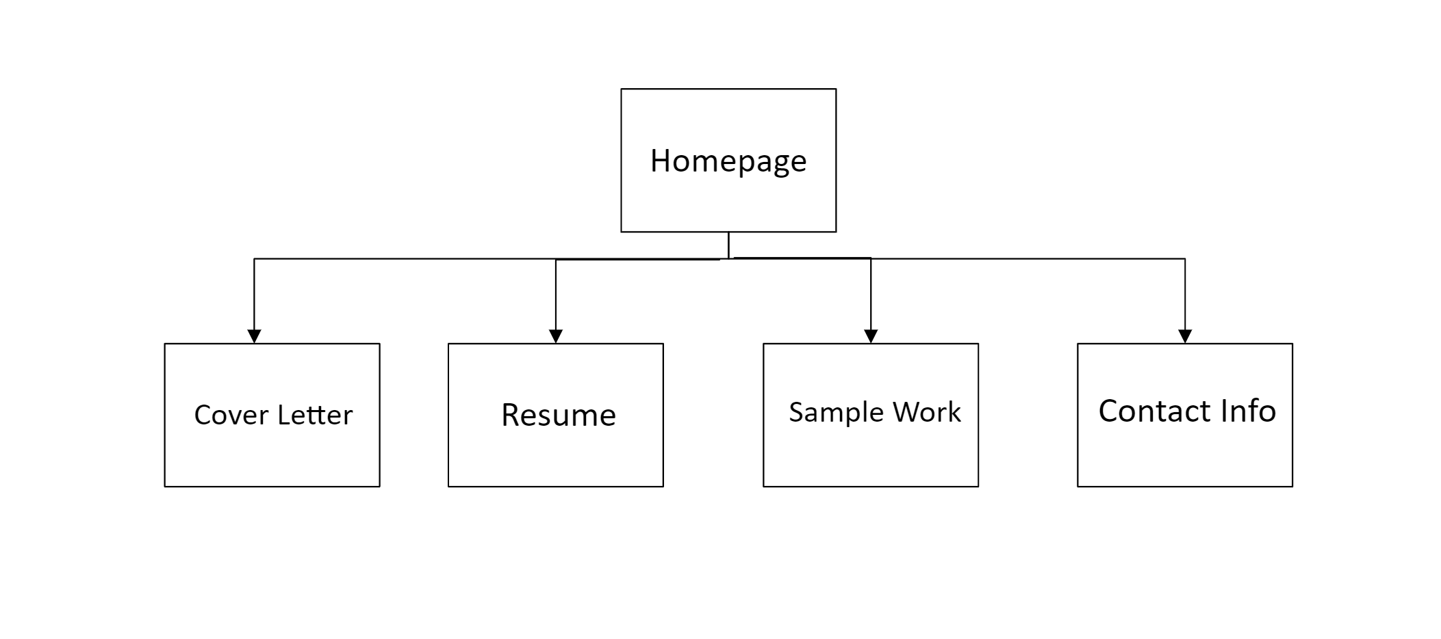

4. Folder Structure Diagram Here

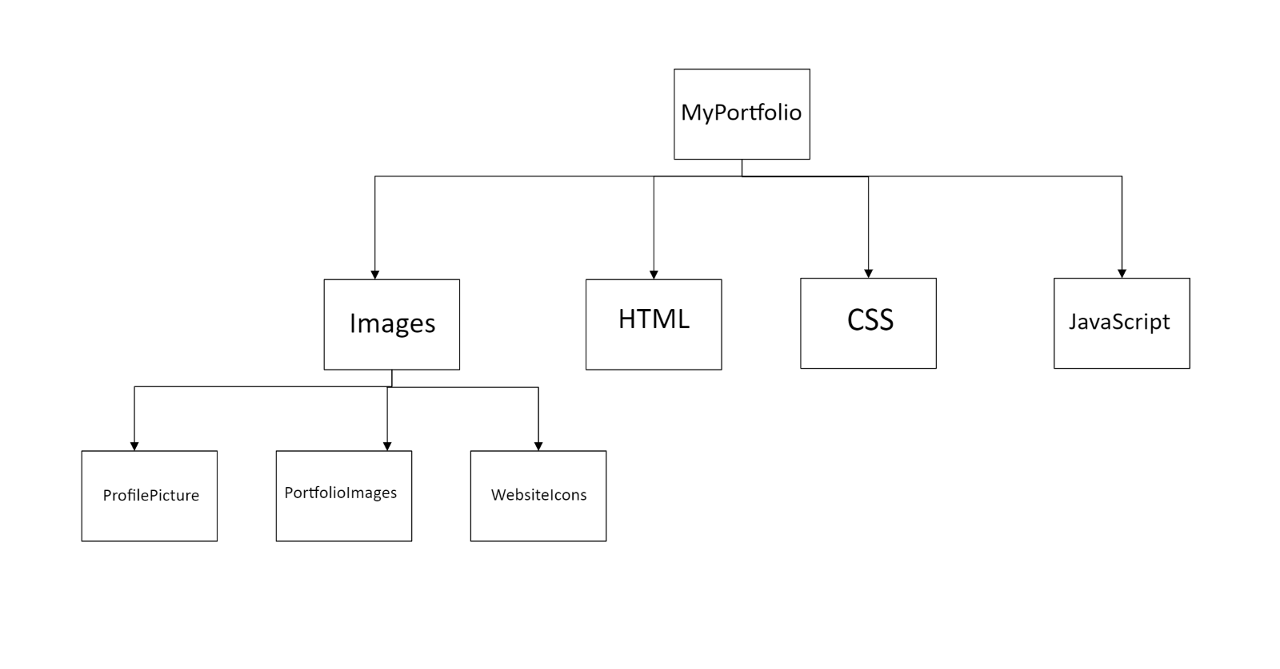

5. Our team's decision to design an example portfolio stems from our deep understanding of its significance. As students, we recognize the necessity of a well-crafted portfolio for future employment. By creating this faux portfolio, we are not just practicing how to create a real website, but also mastering the art of crafting an intriguing and interactive portfolio.

6. Our website, crafted with HTML 5, CSS, and JavaScript, will be a testament to our commitment to interactivity. We plan to incorporate rollovers and slideshows to display example images, ensuring our website is a dynamic and engaging platform.